A Guideline for the Preparation of the Paper

A. Nakai^{1*}, N. Nanami² and L.L. Lebel³ (Times new roman 12 pt, centered-aligned)

¹Affiliation, Address (Times new roman 12 pt, center-aligned)
²Affiliation, Address (Times new roman 12 pt, center-aligned)
³Affiliation, Address (Times new roman 12 pt, center-aligned)
*e-mail address of the corresponding author (Times new roman 12 pt, center-aligned)

Keywords: A maximum of 4 keywords, Separated by commas (Times new roman 12 pt, single-line spacing, left-aligned text).

ABSTRACT
Please prepare your manuscript in English using Microsoft Word software, in either the .doc or .docx format, using North American letter-size (8.5 x 11 inches) or European A4-size (210 x 297 mm).
The manuscript should be formatted using either the template provided or according to the following guidelines and must be submitted via email to cjvwc@gifu-u.ac.jp by May 31st, 2018. For a manuscript to be included in the conference proceedings, one of the authors must register for the conference, and present the paper.
The abstract should not exceed 200 words, with the text being fully justified with the first line indented 0.5 inches, or 1.27 cm. The text of the abstract is Times New Roman 12-point font single-spaced. Standard margins on this page are 1.15” left and right, 1.25” top and bottom.
The manuscript should not exceed 8 pages in length. The manuscript should include text, figures, tables, and references, and SI units should be used. The document should include the following items only in this order: Title, Authors, Affiliations, Keywords, Abstract, and Texts. Please note that the total file size should not exceed 3 MB.
If you have any questions or need assistance with the preparation of your manuscript, please contact the conference secretariat displayed below:

Norimichi Nanami PhD
Secretariat, 13CJWC
Department of Mechanical Engineering
Gufu University, Gifu, 501-1193, Japan
Email: nnanami@gifu-u.ac.jp

INTRODUCTION (first-order heading)
The first-order headings, such as ABSTRACT, INTRODUCTION, TEXT PARAGRAPH, ARTWORK, MATHEMATICAL EQUATIONS, and REFERENCES, shown in this example template, should be in bold caps with 2 line spaces above and 1 line space below them.

Second-level Heading
Second-order subheads should be in bold with main words capitalized with 1 line space above and below them.

Third-level Heading
Third-order subheads should be underlined with main words capitalized with 1 line space above and below them. They are positioned at the left margin.

TEXT paragraph
Standard margins on the manuscript are 1.15” left and right, 1.25” top and bottom. The text being fully justified with the first line indented 0.5 inches, or 1.27 cm. The text paragraphs in the manuscript is Times New Roman 12-point font single-spaced. Paragraphs are NOT separated with a blank line.
The document should include the following items only in this order: Title, Authors, Affiliations, Keywords, Abstract, and Texts. The title should have the initial letter of each major word capitalized and should be bold-faced and centered. The title should be as concise as possible. Add two blank lines before the author list. Authors should be separated by commas. Affiliations should follow on the next line with a blank line. Numbers should appear after the authors' names and then before each affiliation. Keywords should not be more than 4 and separated by commas. Leave a blank line before and two blank lines after the keywords.

ARTWORK
Artwork (photographs, tables, or figures) should be inserted in the manuscript file and be placed as close to the first mention of the artwork as possible. Each figure including captions should be separated from the adjacent text with two blank lines (see Figure 1). Artwork and captions should be centered between the left and right margins.
A caption consisting of the word “Figure”, the figure number, the figure title, in 10 point Helvetica font should appear centered below each figure. All figures should be consecutively numbered with Arabic numerals. Similarly, the captions for the other artwork should appear in the manuscript.

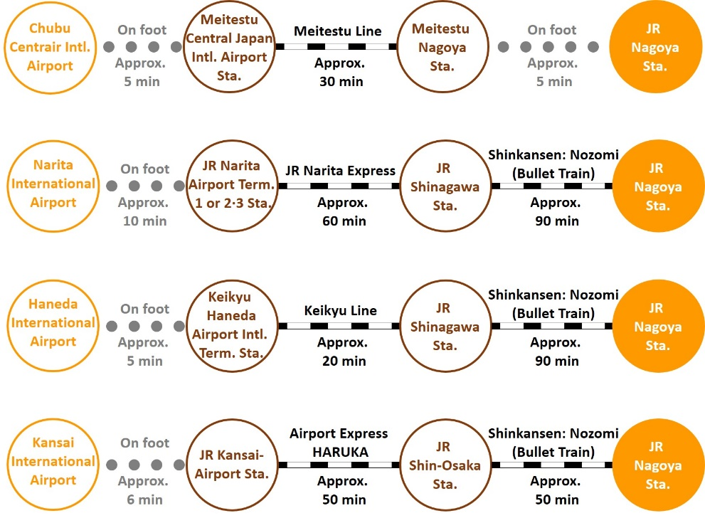
Figure 1. Travel between the JR Nagoya Station/airport

MATHEMATICAL EQUATIONS
Mathematical equations should be centered between left and right margins and should be separated by one blank line. All equations should be numbered consecutively throughout the text, using Arabic numerals in parentheses along the right margin.

a/b = 1 (1)

a + b = c (2)

REFERENCES
It is recommend that the Vancouver Style is used for the references of the manuscript. The first time a particular source (article, book, etc.) is cited in the text, it should be assigned a number and placed in the list of references at the end of the paper. References should be set in 10-point type.

- Ashcroft IA, Hughes DJ, Shaw SJ, et al. Effect of Temperature on the Quasi-static Strength and Fatigue Resistance of Bonded Composite Double Lap Joints. J Adhes 2001; 75: 61-88. DOI: 10.1080/00218460108029594.
- Mallick PK. Fiber-Reinforced Composites: Materials, Manufacturing, and Design. New York: Marcel Dekker. INC., 1988, p. 421.

